|  |  |
| --- | --- |
| **Name:** | MANSI UNIYAL |
| **Roll Number:** | 19EE10039 |

**Experiment No. 13**

**Name of the Experiment: RC Frequency Response**

1. **Aim of the experiment**
2. Explain RC Voltage Dividers
3. Explain RC Circuit as a Low Pass Filter
4. Explain RC Circuit as a High Pass Filter
5. **Tools used:**

* Resistor,
* Capacitor,
* Voltage source
* Stimulation: Vlabs

1. **Background knowledge (brief):**
2. RC Circuit as Filters
   1. Filter – circuit that allows to pass a specified range of frequency components, while blocking or “attenuating” the rest according to the frequency range of signals.
   2. Commonly used filter designs:
      1. The Low Pass Filter
      2. The High Pass Filter
      3. The Band Pass Filter
   3. Filters can also be classified according to the types of components that are used to implement the circuit.
3. RC Voltage Dividers
   1. Let us consider RC circuits as voltage dividers to understand how they would perform as filters.
   2. Note that Vout = (Z2/ Z1 + Z2) * Vin. In this case – Since Z1 or Z2 is dependent upon frequency, the output is dependent upon the frequency of the input waveform.

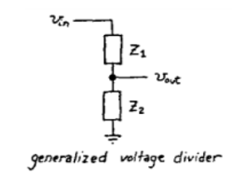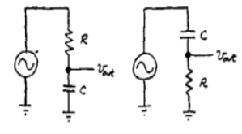

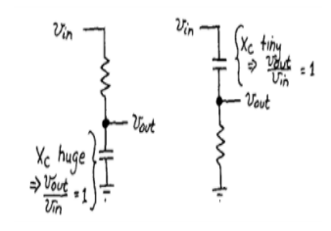

1. RC as Low Pass filter
   1. A simple passive RC Low Pass Filter or LPF, can be easily made by connecting together in series a single Resistor with a single Capacitor as shown below

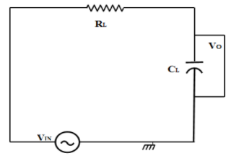

* 1. In this type of filter arrangement, the input signal (Vin) is applied to the series combination (both the Resistor and Capacitor together) but the output signal (Vout) is taken across the capacitor only.
  2. The reactance of a capacitor varies inversely with frequency, while the value of the resistor remains constant as the frequency changes.
  3. At low frequencies the capacitive reactance, (XC) of the capacitor will be very large compared to the resistive value of the resistor R.
  4. Voltage across the capacitor will be much larger than the voltage drop developed across the resistor.
  5. At high frequencies the reverse is true with (VC) being small and (VR) being large due to the change in the capacitive reactance value. Thus, low frequencies are passed and high frequencies are blocked.

1. Cut-off Frequency
   1. The cutoff frequency of an RC low-pass filter is the frequency at which the amplitude of the input signal is reduced by 3 dB (this value was chosen because a 3 dB reduction in amplitude corresponds to a 50% reduction in power).
   2. Thus, the cutoff frequency is also called the –3 dB frequency. The term bandwidth refers to the width of a filter’s passband, and in the case of a low-pass filter, the bandwidth is equal to the –3 dB frequency. The cutoff frequency (fc) of an RC low-pass filter is calculated as follows:



1. Capacitive Reactance
   1. The reactance of a capacitor indicates the amount of opposition to current flow, but unlike resistance, the amount of opposition depends on the frequency of the signal passing through the capacitor.
   2. Thus, to calculate reactance at a specific frequency, following equation is used:

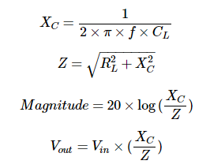

1. Low-Pass Filter Phase Shift
   1. Each reactive element in a circuit introduces 90° of phase shift, but this phase shift does not happen all at once.
   2. The phase of the output signal, just like the magnitude of the output signal, changes gradually as the input frequency increases. In an RC low-pass filter, we have one reactive element i.e. the capacitor, and consequently the circuit will eventually introduce 90° of phase shift.



1. High pass filter
   1. A simple passive RC High Pass Filter or HPF, can be easily made by connecting together in series a single Resistor with a single Capacitor as shown below.

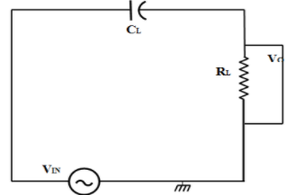

* 1. In this type of filter arrangement, the input signal (Vin) is applied to the series combination (both the Resistor and Capacitor together) but the output signal (Vout) is taken across the resistor only.
  2. In this circuit, the reactance of the capacitor is very high at low frequencies so the capacitor acts like an open circuit and blocks any input signals at (Vin) until the cut-off frequency point (fc) is reached.
  3. Above this cut-off frequency point the reactance of the capacitor has reduced sufficiently as to now act more like a short circuit allowing all of the input signal to pass directly to the output as shown below in the filter’s response curve.

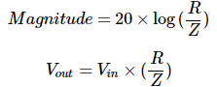

1. **Circuit (hand drawn/image)**

RC Frequency Response LPF RC Frequency Response HPF

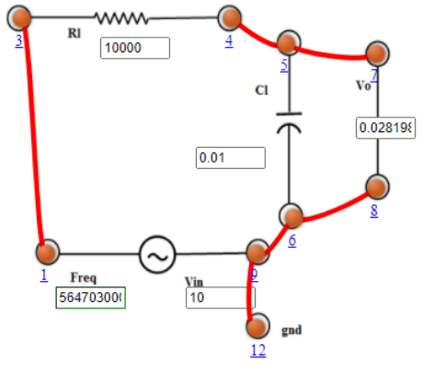 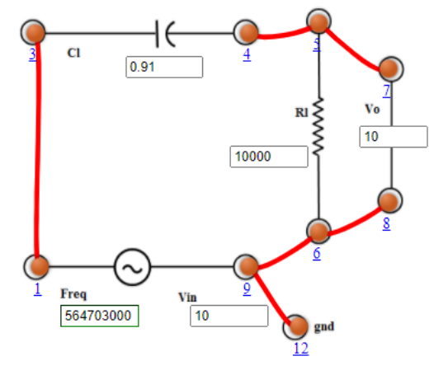

1. **Measurement Data (Tabular form)**

RC Frequency Response LPF RC Frequency Response HPF

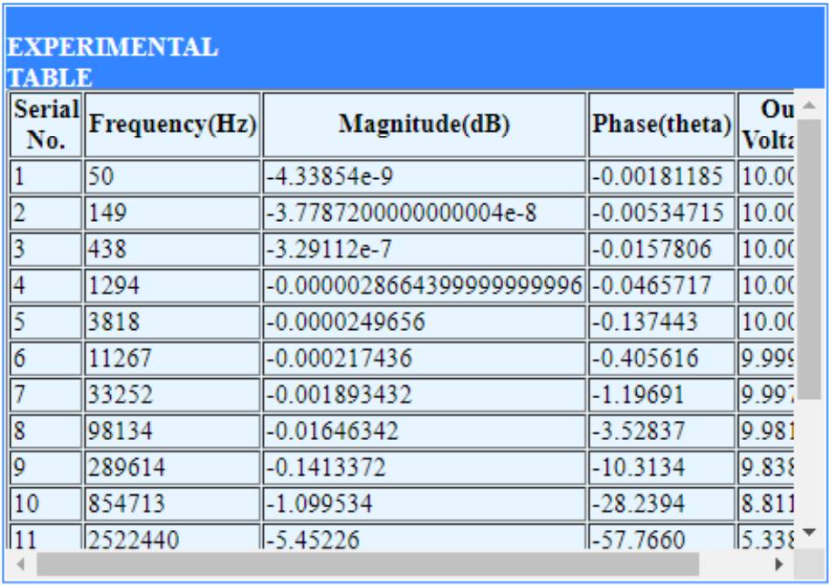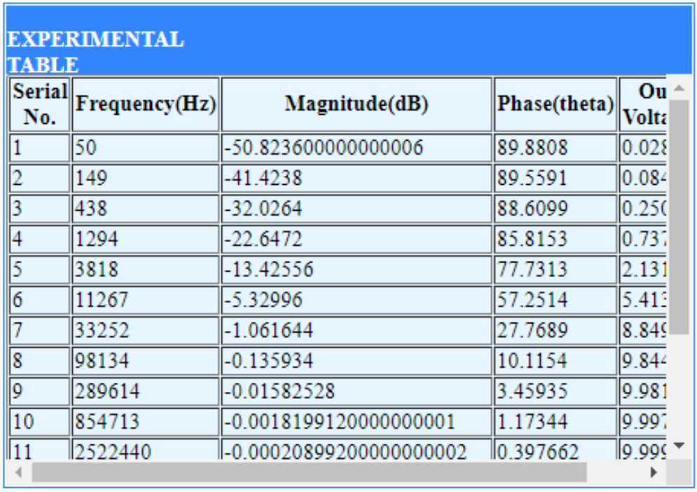

1. **Graph (Image)/Screenshots**

RC Frequency Response LPF – Frequency Response

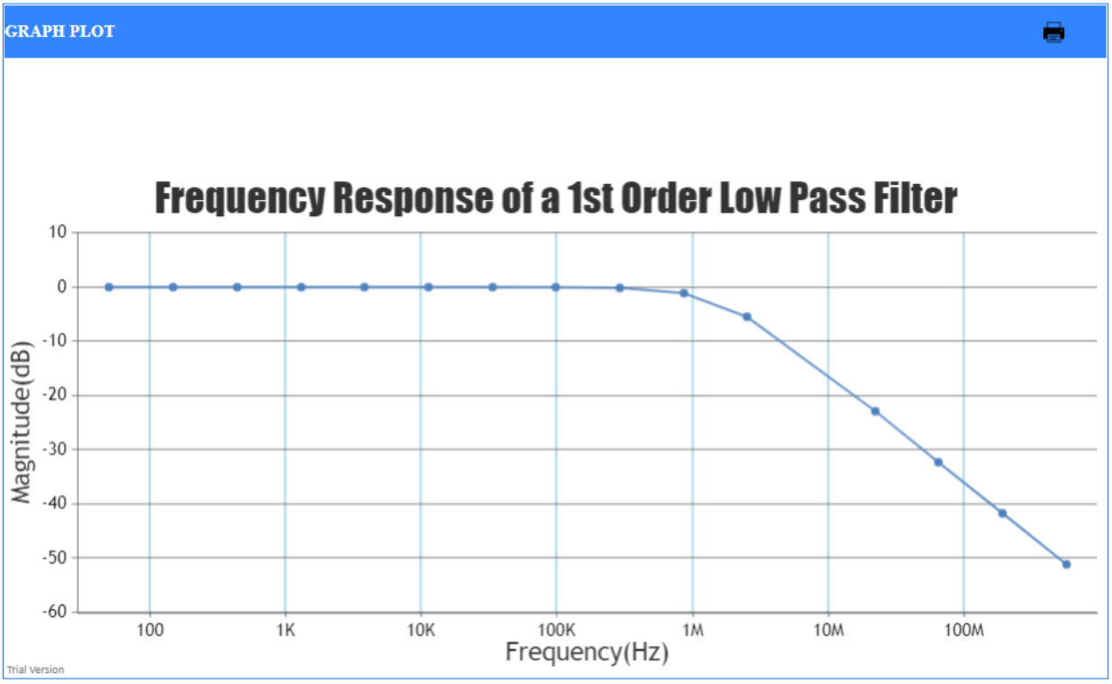

RC Frequency Response LPF – Phase

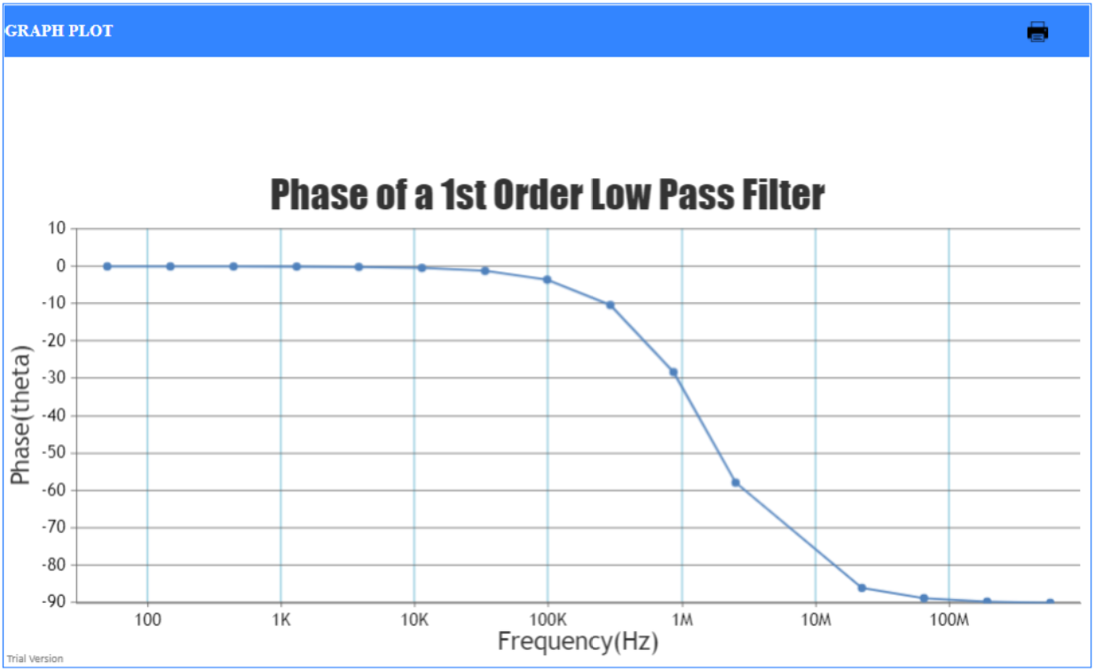

RC Frequency Response HPF – Frequency Response

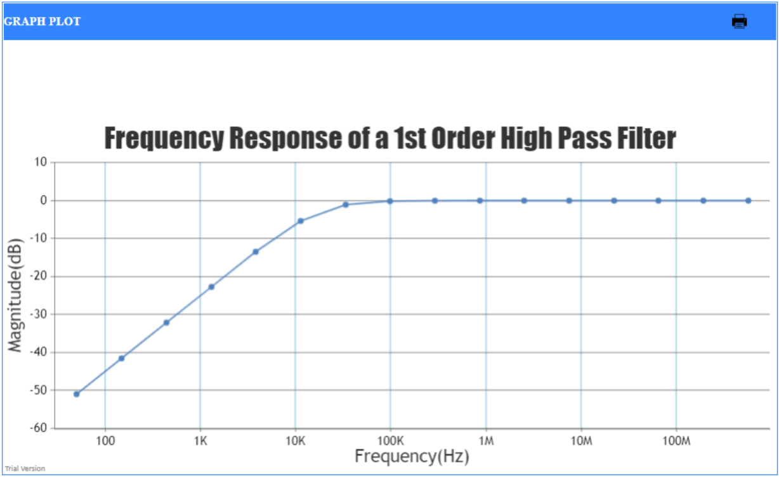

RC Frequency Response HPF – Phase

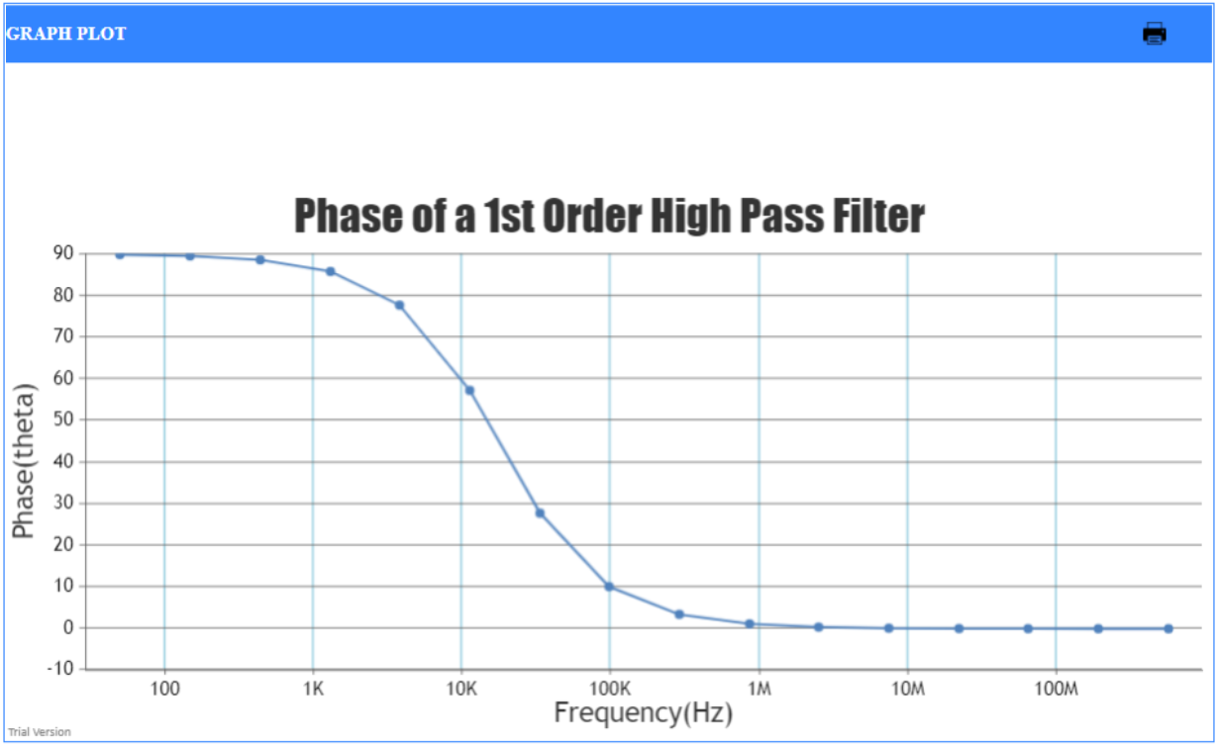

1. **Conclusion**

RC circuits can be used as HPF and LPF

1. **Discussions**
   1. A low pass filters (LPFs) are important building blocks for many analog integrated circuit design. The biomedical applications or the sensor applications require the LPFs with very low cut-off frequency.
   2. The simplest way to implement the LPF is using the passive RC filter. The passive RC LPF, however, consumes large chip area when the desired time constant is large. The transconductance-C (gm-C) filter or the switched capacitor (SC) filters are widely used to achieve the low cut-off frequency in limited area.
2. **Quiz**

